**Supplementary Information for**

**“Mapping herbivore-accessible biomass across a heterogeneous mountain landscape using multisensor high-resolution UAV data”**

Authors: Annika M. Zuleger, Martina M. Viti, Luise Quoss, Filipe S. Dias, Luís Borda de Água, Miguel N. Bugalho & Henrique M. Pereira

Date: July, 2025

Corresponding Author:

Annika Zuleger

German Centre for Integrative Biodiversity Research (iDiv) Halle-Jena-Leipzig, Leipzig, Germany

Martin-Luther University Halle-Wittenberg, Halle (Saale), Germany

Email: annika_mikaela.zuleger@idiv.de

__________________________________________________________________________________

**S1. EnMAP Box Random Forest Land-use Classification Performance.** Detailed summary of the performance metrics obtained from applying a Random Forest classifier to EnMAP Box data for land-use mapping. The tables include the confusion matrix, overall accuracy, class-wise accuracies, proportion matrix and class-wise proportion.

**S1.1 Confusion Matrix** showing the performance of the land-use classification, including true positive, false positive, true negative, and false negative values for each class.

|  |  |  |  |  |  |  |  |  |  |
| --- | --- | --- | --- | --- | --- | --- | --- | --- | --- |
|  | **Reference Class** | | | | | | | |  |
| **Oak Forest** | **Pine Forest** | **High Shrub** | **Low Shrub** | **Rock** | **Agriculture** | **Urban** | **Water** | **Sum** |
| **Oak Forest** | 215,855 | 14,040 | 3,553 | 3,127 | 2,630 | 2,269 | 3,926 | 608 | 246,008 |
| **Pine Forest** | 11,302 | 22,091 | 823 | 286 | 652 | 44 | 673 | 29 | 35,900 |
| **High Shrub** | 5,840 | 1,108 | 15,311 | 11,594 | 4,423 | 120 | 4,641 | 79 | 43,116 |
| **Low Shrub** | 8,687 | 394 | 12,443 | 32,589 | 15,683 | 3,140 | 3,028 | 72 | 76,036 |
| **Rock** | 809 | 243 | 3,174 | 6,586 | 197,565 | 82 | 15,317 | 1,172 | 224,948 |
| **Agriculture** | 3,383 | 67 | 443 | 2,821 | 340 | 26,461 | 6,255 | 9 | 39,779 |
| **Urban** | 3,197 | 981 | 2,475 | 2,144 | 14,759 | 2,210 | 58,137 | 600 | 84,503 |
| **Water** | 532 | 181 | 181 | 115 | 4,038 | 13 | 2,119 | 2,594 | 9,773 |
| **Sum** | 249,605 | 39,105 | 38,403 | 59,262 | 240,090 | 34,339 | 94,096 | 5,163 | 760,063 |

**S1.2. Accuracies** including Overall Accuracy, Kappa Accuracy and Mean F1 Accuracy to evaluate overall model performance and classification balance.

|  |  |  |  |
| --- | --- | --- | --- |
| **Measure** | **Estimate [%]** | **95 % Confidence Interval [%]** | |
| Overall Accuracy | 73.08 | 73.00 | 73.17 |
| Kappa Accuracy | 65.59 | 65.47 | 65.71 |
| Mean F1 Accuracy | 55.48 | - | - |

**S1.3. Class-wise Accuracies,** including user's accuracy, producer's accuracy, and F1 score for each land-use class. These metrics provide insights into both the reliability of the classification for each class (user's accuracy), the completeness of the classification for each class (producer's accuracy), and the balance between precision and recall (F1 score).

|  |  |  |  |  |  |  |  |  |  |
| --- | --- | --- | --- | --- | --- | --- | --- | --- | --- |
|  | **User's Accuracy [%]** | | | **Producer's Accuracy [%]** | | | **F1 Accuracy** | | |
| **Estimate** | **95 % Interval** | | **Estimate** | **95 % Interval** | | **Estimate** | **95 % Interval** | |
| **Oak Forest** | 86.48 | 86.4 | 86.55 | 87.74 | 87.63 | 87.86 | 87.11 | 87.02 | 87.19 |
| **Pine Forest** | 56.49 | 56.38 | 56.6 | 61.53 | 61.12 | 61.95 | 58.91 | 58.76 | 59.05 |
| **High Shrub** | 39.87 | 39.76 | 39.98 | 35.51 | 35.09 | 35.93 | 37.56 | 37.42 | 37.71 |
| **Low Shrub** | 54.99 | 54.88 | 55.1 | 42.86 | 42.52 | 43.2 | 48.17 | 48.02 | 48.32 |
| **Rock** | 79.58 | 79.51 | 79.66 | 88.34 | 88.2 | 88.47 | 83.73 | 83.64 | 83.82 |
| **Agriculture** | 55.06 | 54.95 | 55.17 | 43.65 | 43.06 | 44.23 | 48.69 | 48.54 | 48.85 |
| **Urban** | 61.15 | 61.04 | 61.25 | 68.94 | 68.69 | 69.2 | 64.81 | 64.67 | 64.95 |
| **Water** | 50.24 | 50.14 | 50.34 | 26.54 | 25.27 | 27.81 | 34.73 | 34.59 | 34.87 |

**S1.4. Proportion Matrix** showing the proportions of predicted samples for each reference class. The diagonal values indicate the proportion of correctly classified samples, while the off-diagonal values represent misclassifications across different classes.

|  |  |  |  |  |  |  |  |  |  |
| --- | --- | --- | --- | --- | --- | --- | --- | --- | --- |
|  | **Reference Class** | | | | | | | |  |
| **Oak Forest** | **Pine Forest** | **High Shrub** | **Low Shrub** | **Rock** | **Agriculture** | **Urban** | **Water** | **Sum** |
| **Oak Forest** | 0.284 | 0.0149 | 0.0077 | 0.0114 | 0.0011 | 0.0045 | 0.0042 | 0.0007 | 0.3284 |
| **Pine Forest** | 0.0185 | 0.0291 | 0.0015 | 0.0005 | 0.0003 | 0.0001 | 0.0013 | 0.0002 | 0.0514 |
| **High Shrub** | 0.0047 | 0.0011 | 0.0201 | 0.0164 | 0.0042 | 0.0006 | 0.0033 | 0.0002 | 0.0505 |
| **Low Shrub** | 0.0041 | 0.0004 | 0.0153 | 0.0429 | 0.0087 | 0.0038 | 0.0028 | 0.0002 | 0.078 |
| **Rock** | 0.0035 | 0.0009 | 0.0058 | 0.0206 | 0.2599 | 0.0005 | 0.0193 | 0.0053 | 0.3159 |
| **Agriculture** | 0.003 | 0.0001 | 0.0002 | 0.0041 | 0.0001 | 0.0349 | 0.003 | 0 | 0.0451 |
| **Urban** | 0.0052 | 0.0009 | 0.0061 | 0.004 | 0.0203 | 0.0082 | 0.0765 | 0.0028 | 0.1238 |
| **Water** | 0.0008 | 0 | 0.0001 | 0.0001 | 0.0016 | 0 | 0.0008 | 0.0034 | 0.0068 |
| **Sum** | 0.3237 | 0.0472 | 0.0567 | 0.1 | 0.2959 | 0.0523 | 0.1112 | 0.0129 | 1 |

**S1.5 Class-wise Proportion** estimates for land-use classification, showing the estimated proportions of each reference class with their associated 95% confidence intervals.

|  |  |  |  |
| --- | --- | --- | --- |
|  | **Proportion** | | |
| **Estimate** | **95 % Interval** | |
| **Oak Forest** | 0.3284 | 0.3278 | 0.329 |
| **Pine Forest** | 0.0514 | 0.0511 | 0.0518 |
| **High Shrub** | 0.0505 | 0.05 | 0.051 |
| **Low Shrub** | 0.078 | 0.0774 | 0.0786 |
| **Rock** | 0.3159 | 0.3151 | 0.3167 |
| **Agriculture** | 0.0451 | 0.0446 | 0.0457 |
| **Urban** | 0.1238 | 0.1232 | 0.1244 |
| **Water** | 0.0068 | 0.0065 | 0.007 |

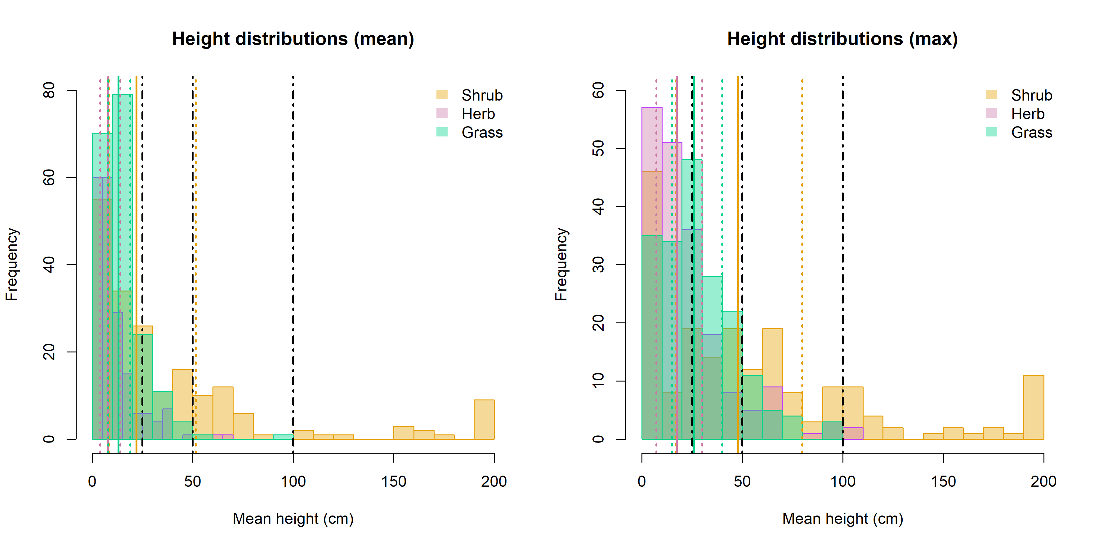**S2. Height distributions of field samples.** Left: Mean vegetation height by vegetation type. Right: Maximum vegetation height by vegetation type. Dotted lines indicate the 25th and 75th percentiles; solid lines represent the mean. Black dot-dashed lines denote the height interval thresholds used for vegetation relative density (VRD) and percentage height (PH) estimation.

**S3. Allometric equations used for shrub biomass estimation** following Vega et al. (2022):

Shrub biomass (B) was calculated as

$B = b_{0} * C^{ b_{1}} * {\underline{H}}^{{ b}_{2}}$ Eq. 1

where *C* is the percentage cover and *H* the average height of the respective species. *b0*, *b1* and *b2* are species specific parameters that were then used to estimate the biomass for the data collected in May, 2024. For ease of estimation, Equation 1 was transformed to a linear regression using a logarithmic transformation:

$log(B) = {log(b}_{0}) + b_{1}log(C) +b_{2}log(\underline{H})$ Eq. 2

**S3.1 Coefficients per species**, as obtained from fitting the formula above. n2023 refers to the number of samples per species collected during the 2023 field sampling campaign.

|  |  |  |  |  |
| --- | --- | --- | --- | --- |
| **Species** | **n2023** | **b0** | **b1** | **b2** |
| *Calluna vulgaris* | 26 | 1.39 ± 0.37 | -0.07 ± 0.08 | 1.05 ± 0.10 |
| *Cytisus spp* | 15 | 1.92 ± 0.65 | 0.00 ± 0.10 | 1.14 ± 0.22 |
| *Daboecia spp* | 10 | -1.66 ± 1.06 | 0.90 ± 0.29 | 1.77 ± 0.45 |
| *Erica arborea* | 30 | 1.26 ± 0.27 | 0.01 ± 0.06 | 1.13 ± 0.07 |
| *Erica spp* | 96 | 1.49 ± 0.22 | 0.04 ± 0.06 | 0.97 ± 0.04 |
| *Genista tridentata* | 75 | 1.63 ± 0.23 | 0.06 ± 0.06 | 0.85 ± 0.05 |
| *Rubus spp* | 16 | 0.26 ± 0.22 | 0.06 ± 0.05 | 1.10 ± 0.17 |
| *Ulex europaeus* | 13 | 2.00 ± 0.56 | 0.02 ± 0.13 | 0.92 ± 0.04 |
| *Ulex minor* | 99 | 1.38 ± 0.21 | 0.05 ± 0.06 | 0.91 ± 0.04 |

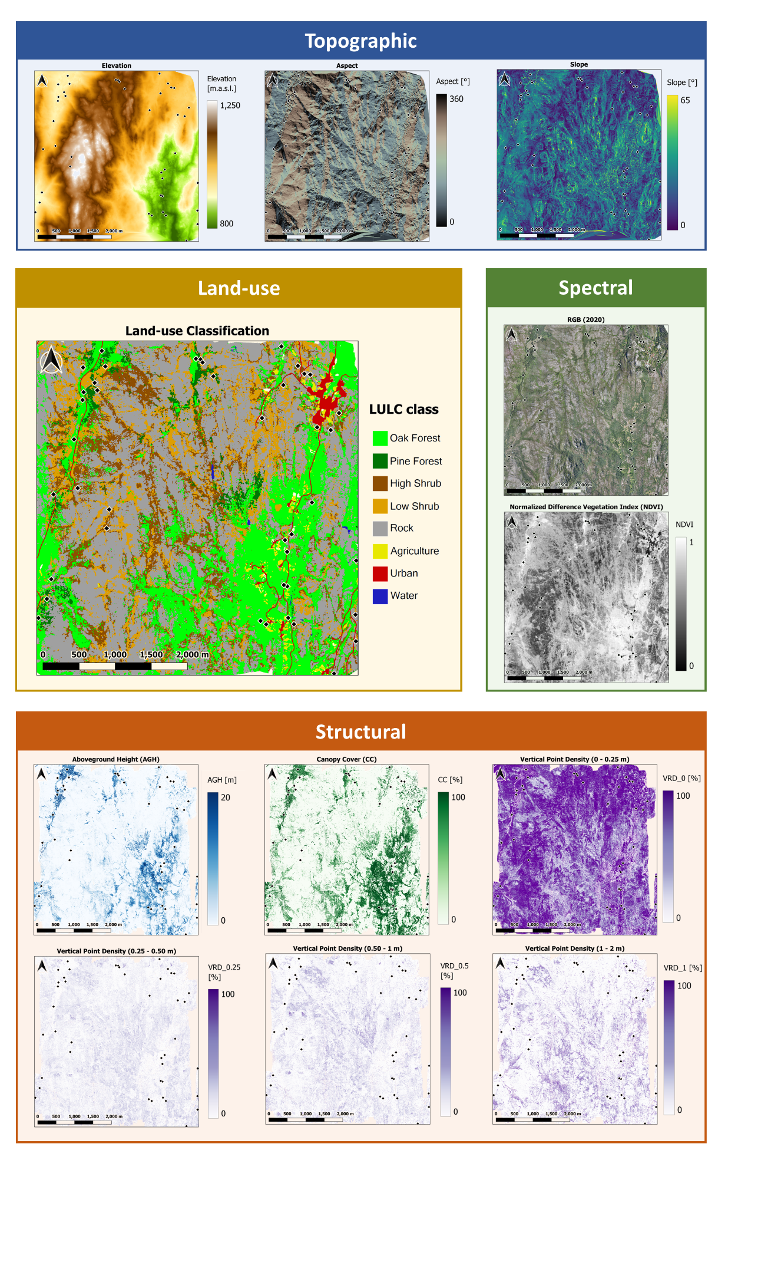**S4. Spatial maps of Remote Sensing Metrics Used in the Study.** Maps display the spatial distribution of key remote sensing metrics, including RGB imagery, land-use/land-cover classification, topographic information, spectral data, and LiDAR-derived measurements, providing a comprehensive overview of the environmental variables analyzed across the study area.

**S5. Variable correlation and Dissimilarity Analysis**

**S5.1. Pairwise correlation plot** between all study variables. This plot displays the correlations between each pair of variables, with the correlation coefficients indicated within the plot. Strong positive and negative correlations are visually highlighted, allowing for easy identification of relationships between the variables considered in the study.

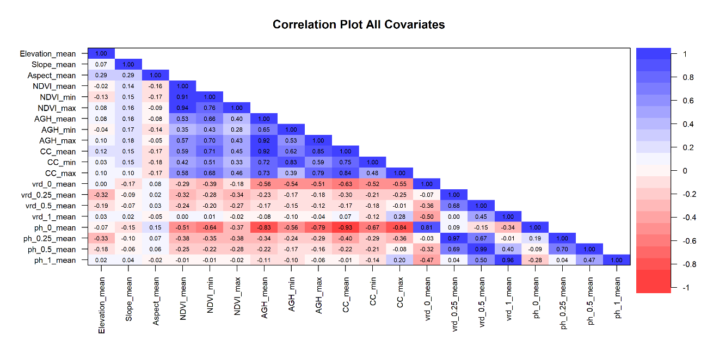

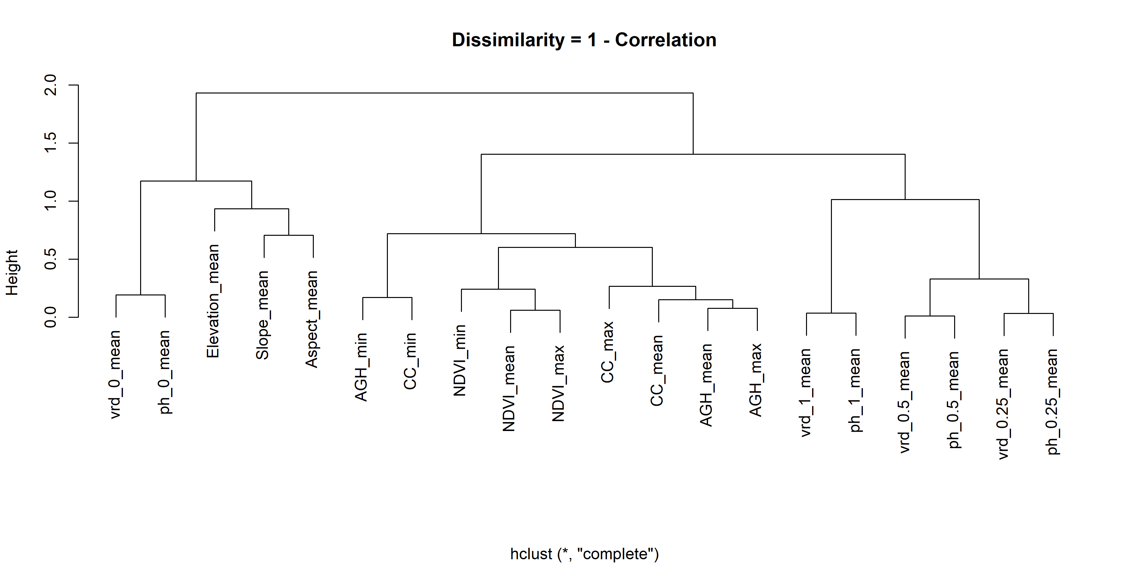**S5.2 Dissimilarity tree** of all variables. This dendrogram illustrates the hierarchical relationships between the variables based on their dissimilarities, highlighting clusters of similar variables and providing insights into how the variables are grouped based on their characteristics.

**S5.3. Variance Inflation Factor (VIF) statistics** for non-correlated variables retained after Spearman rank correlation analysis.



**S6. Field measurements** of herbivore-accessible biomass (HAB) per vegetation type and habitat class. Histograms display the distribution of HAB accessible to herbivores for each vegetation type (forb, grass, herbaceous, shrub) across different habitat classes.

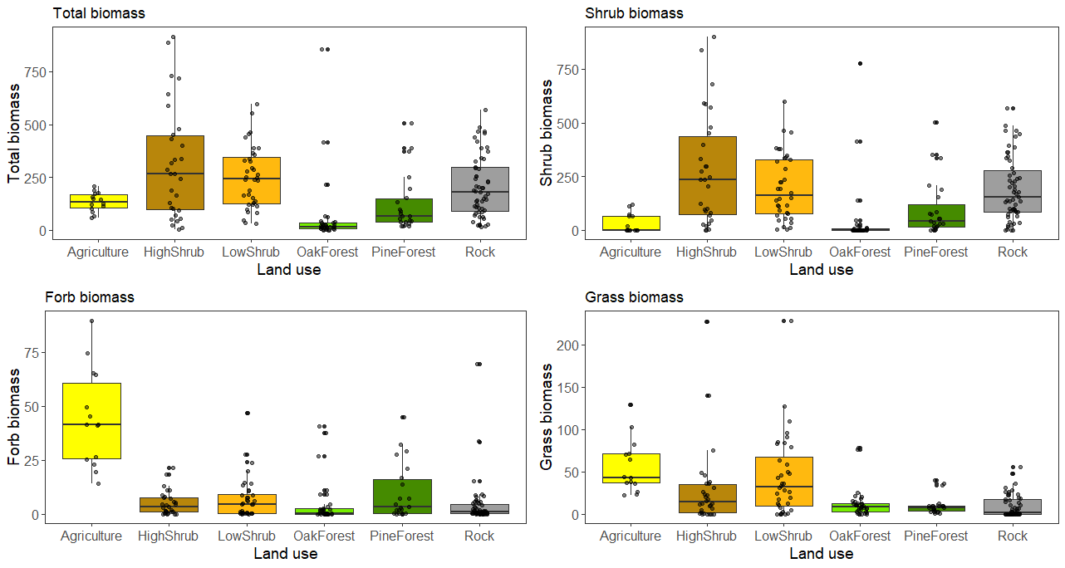

**S7. Model Summaries** for different vegetation types, showing the results of Generalized Additive Mixed Models (GAMM) with a Tweedie distribution and double penalty approach. The table presents the key model fit statistics, including deviance explained, effective degrees of freedom for smoothing terms, significance of predictors, and residual deviance.

|  |  |
| --- | --- |
| **Total HAB** | **Shrub HAB** |
|  |  |
| **Forb HAB** | **Grass HAB** |
|  |  |
| **Herbaceous HAB** |  |
|  |  |

**S8 Relative importance of smooth terms** expressed as F-statistics from generalized additive models predicting forb and grass HAB. The y-axis is presented on a log10 scale to show the range of values. Terms with negligible importance (F ≤ 0.001 across all models) were excluded to improve clarity. Variables are grouped by data type including topographic, spectral, structural, and other categories and colored accordingly.

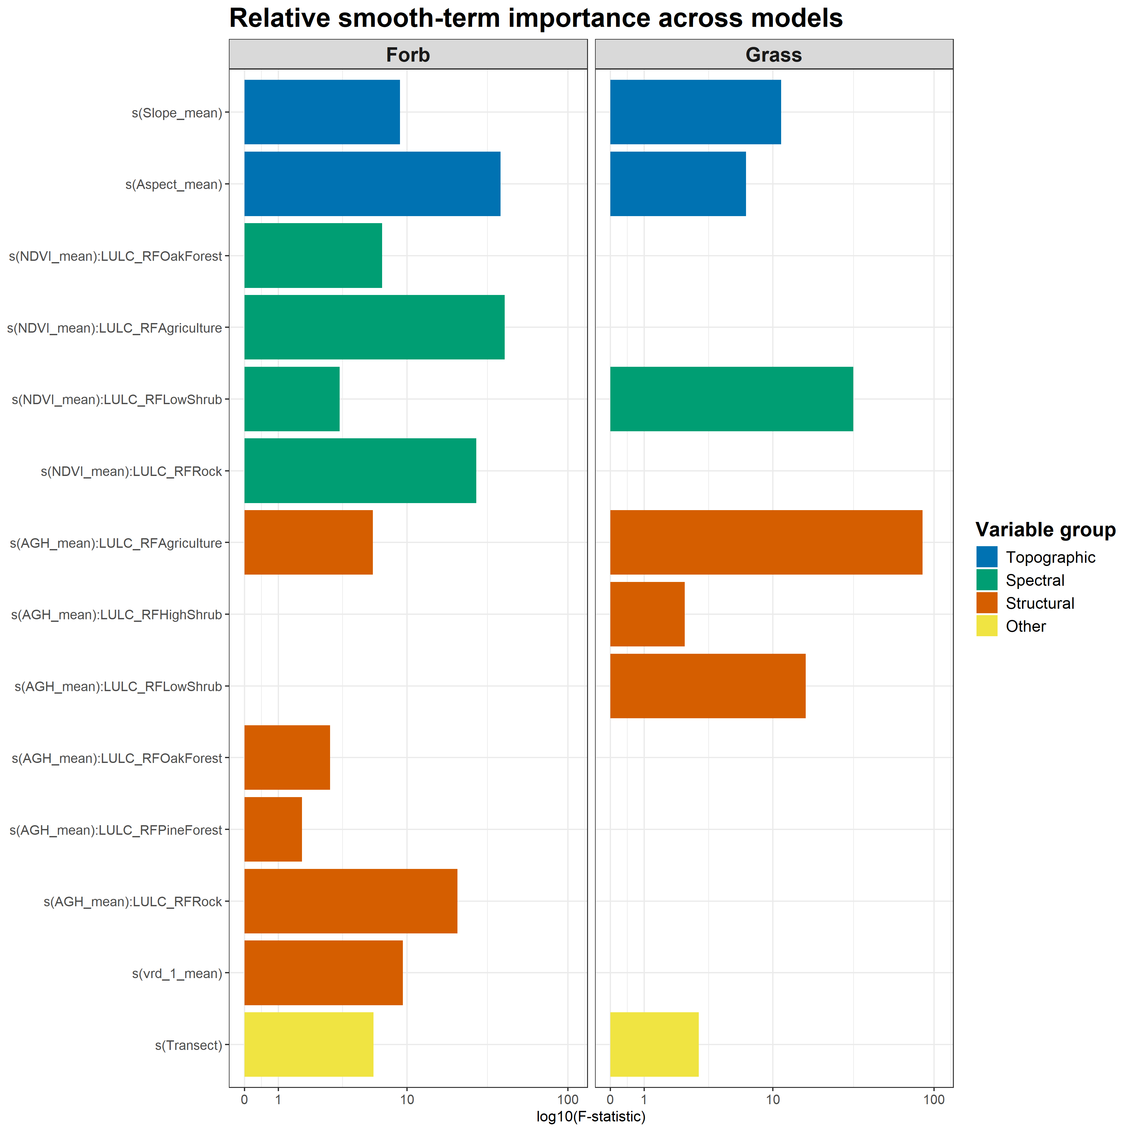

**S9. Moran’s I values** for model residuals of different HAB components (Total, Shrub, Forb, Grass, and Herbs) across neighborhood sizes (k = 1–15).

|  |  |  |  |  |  |
| --- | --- | --- | --- | --- | --- |
| k | Total | Shrub | Forb | Grass | Herbs |
| 1 | -0.23 | -0.20 | -0.22 | -0.10 | -0.12 |
| 2 | -0.20 | -0.10 | -0.11 | -0.03 | -0.05 |
| 3 | -0.19 | -0.08 | -0.17 | -0.02 | -0.08 |
| 4 | -0.15 | -0.05 | -0.12 | 0.01 | -0.05 |
| 5 | -0.11 | -0.04 | -0.10 | 0.04 | -0.01 |
| 6 | -0.10 | -0.03 | -0.09 | 0.06 | 0.01 |
| 7 | -0.08 | -0.02 | -0.08 | 0.05 | -0.01 |
| 8 | -0.07 | -0.02 | -0.07 | 0.05 | 0.00 |
| 9 | -0.07 | -0.02 | -0.07 | 0.06 | 0.01 |
| 10 | -0.06 | -0.01 | -0.06 | 0.06 | 0.01 |
| 11 | -0.05 | -0.01 | -0.05 | 0.05 | 0.01 |
| 12 | -0.05 | 0.00 | -0.04 | 0.04 | 0.01 |
| 13 | -0.04 | 0.00 | -0.05 | 0.05 | 0.02 |
| 14 | -0.04 | 0.00 | -0.04 | 0.05 | 0.02 |
| 15 | -0.04 | 0.00 | -0.04 | 0.05 | 0.02 |

**S10. Predicted vs. observed HAB** across forb HAB (left) and grass HAB (right) using hold-out cross-validation. Predictions were generated using an 80/20 training-validation split at both the habitat and transect levels, ensuring data independence. The blue and red boxplots represent the log HAB predictions of the training (blue) and test (red) datasets, respectively. The dashed 1:1 line represents perfect agreement between predicted and observed values. Key performance metrics, including deviance explained (Dev.Exp), root mean square error (RMSE), bias, and R² are provided for the test set.

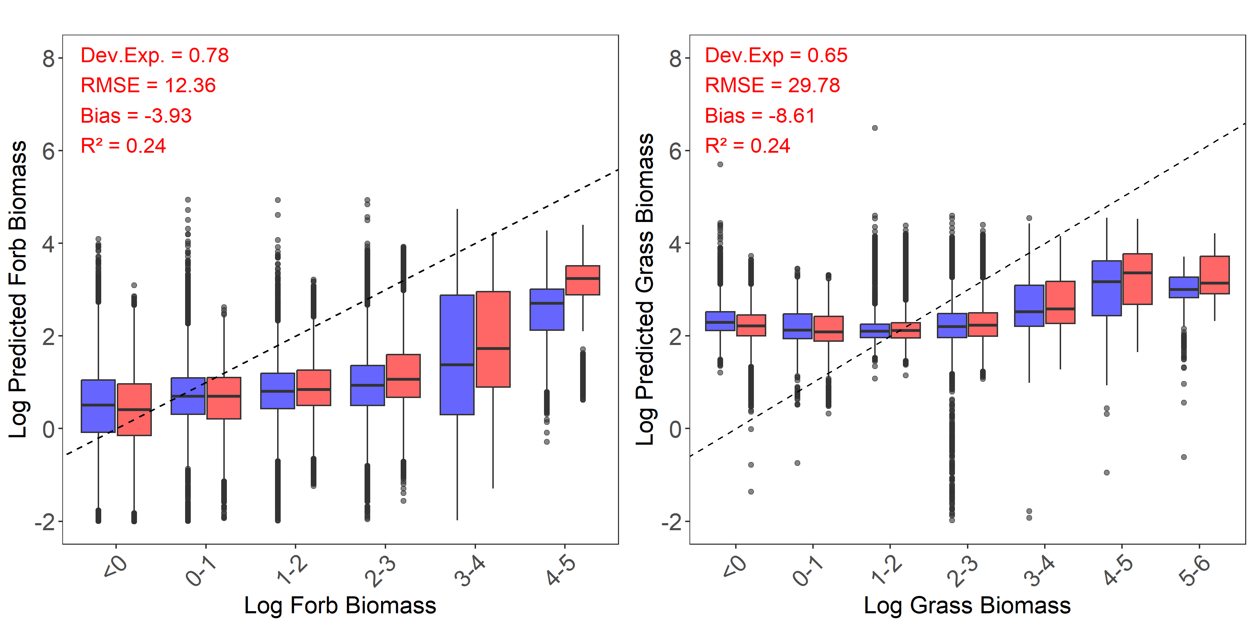

**S11. Summary statistics** (mean, standard deviation, median, and interquartile range) for observed and predicted HAB values (g/m²) across the different vegetation types.

|  |  |  |  |  |  |  |  |  |
| --- | --- | --- | --- | --- | --- | --- | --- | --- |
| **Total HAB** | | | | | | | | |
| **LULC Type** | **Mean (Actual)** | **SD (Actual)** | **Mean (Pred)** | **SD (Pred)** | **Median (Actual)** | **IQR (Actual)** | **Median (Pred)** | **IQR (Pred)** |
| **Agriculture** | 132.88 | 45.6 | 164.89 | 33.72 | 134.35 | 104.83 - 167.13 | 165.88 | 144.36 - 184.21 |
| **HighShrub** | 310.86 | 265.6 | 170.49 | 48.16 | 266.98 | 96.31 - 446.05 | 162.00 | 137.45 - 194.09 |
| **LowShrub** | 249.95 | 146.05 | 183.24 | 33.86 | 244.2 | 124.96 - 343.06 | 180.23 | 160.47 - 202.87 |
| **OakForest** | 63.23 | 164.63 | 85.47 | 61.71 | 15.75 | 6.55 - 33.55 | 72.12 | 33.11 - 124.37 |
| **PineForest** | 123.65 | 136.9 | 94.53 | 40.92 | 66.83 | 38.95 - 148.34 | 86.70 | 66.33 - 113.62 |
| **Rock** | 204.51 | 144.7 | 127.32 | 34.06 | 180.38 | 89.47 - 296.26 | 124.06 | 104.18 - 146.95 |
| **Total** | **191.41** | **184.79** | **130.77** | **55.64** | **137.24** | **43.6 - 287.48** | **130.89** | **97.56 - 166.10** |
|  | | | | | | | | |
| **Shrub HAB** | | | | | | | | |
| **LULC Type** | **Mean (Actual)** | **SD (Actual)** | **Mean (Pred)** | **SD (Pred)** | **Median (Actual)** | **IQR (Actual)** | **Median (Pred)** | **IQR (Pred)** |
| **Agriculture** | 32.22 | 44.59 | 100.14 | 483.62 | 0.05 | 0.00 - 63.83 | 16.67 | 6.30 - 52.86 |
| **HighShrub** | 276.84 | 258.21 | 142.11 | 50.51 | 236.09 | 71.48 - 437.69 | 131.36 | 107.03 - 166.40 |
| **LowShrub** | 198.5 | 153.4 | 133.03 | 33.90 | 160.79 | 74.79 - 328.79 | 126.66 | 109.23 - 149.85 |
| **OakForest** | 42.62 | 149.41 | 71.24 | 69.63 | 0.01 | 0.00 - 6.06 | 50.33 | 16.40 - 107.27 |
| **PineForest** | 98.85 | 134.39 | 68.27 | 46.27 | 42.17 | 15.21 - 117.59 | 55.46 | 38.81 - 83.81 |
| **Rock** | 191.28 | 148.26 | 100.55 | 36.55 | 152.11 | 84.04 - 278.14 | 93.54 | 74.61 - 119.40 |
| **Total** | **157.01** | **183.08** | **102.81** | **76.35** | **88.18** | **7.69 - 240.98** | **99.37** | **68.90 - 132.02** |
|  | | | | | | | | |
| **Forb HAB** | | | | | | | | |
| **LULC Type** | **Mean (Actual)** | **SD (Actual)** | **Mean (Pred)** | **SD (Pred)** | **Median (Actual)** | **IQR (Actual)** | **Median (Pred)** | **IQR (Pred)** |
| **Agriculture** | 44.25 | 22.42 | 23.77 | 8.36 | 41.30 | 25.58 - 60.73 | 23.44 | 17.20 - 29.49 |
| **HighShrub** | 4.86 | 5.54 | 4.56 | 1.95 | 3.15 | 0.85 - 7.58 | 4.18 | 2.96 - 5.95 |
| **LowShrub** | 7.12 | 9.79 | 4.21 | 1.61 | 4.60 | 0.27 - 9.17 | 4.07 | 2.71 - 5.47 |
| **OakForest** | 4.76 | 10.26 | 1.69 | 0.70 | 0.20 | 0.00 - 2.70 | 1.64 | 1.11 - 2.17 |
| **PineForest** | 9.84 | 13.09 | 1.84 | 1.00 | 3.15 | 0.15 - 15.92 | 1.61 | 1.08 - 2.41 |
| **Rock** | 4.05 | 10.39 | 3.29 | 2.39 | 1.10 | 0.10 - 4.40 | 2.84 | 1.38 - 4.54 |
| **Total** | **8.51** | **15.18** | **3.42** | **3.27** | **1.90** | **0.10 - 8.57** | **2.64** | **1.55 - 4.49** |
|  | | | | | | | | |
| **Grass HAB** | | | | | | | | |
| **LULC Type** | **Mean (Actual)** | **SD (Actual)** | **Mean (Pred)** | **SD (Pred)** | **Median (Actual)** | **IQR (Actual)** | **Median (Pred)** | **IQR (Pred)** |
| **Agriculture** | 56.41 | 31.94 | 38.80 | 10.72 | 43.05 | 36.52 - 70.97 | 38.89 | 31.15 - 45.75 |
| **HighShrub** | 29.16 | 47.09 | 11.50 | 3.10 | 14.00 | 2.08 - 34.8 | 11.12 | 9.31 - 13.30 |
| **LowShrub** | 44.33 | 47.46 | 19.28 | 7.21 | 31.8 | 9.92 - 67.62 | 17.99 | 14.22 - 23.05 |
| **OakForest** | 12.68 | 17.91 | 6.70 | 2.11 | 8.10 | 2.70 - 12.8 | 6.43 | 5.13 - 8.02 |
| **PineForest** | 10.24 | 11.14 | 7.11 | 2.17 | 8.00 | 3.30 - 9.70 | 6.99 | 5.65 - 8.53 |
| **Rock** | 9.18 | 13.25 | 7.51 | 2.23 | 1.40 | 0.00 - 16.90 | 7.39 | 5.89 - 8.96 |
| **Total** | **23.14** | **34.78** | **9.96** | **6.55** | **10.30** | **1.10 - 29.65** | **8.14** | **6.16 - 11.10** |
|  | | | | | | | | |
| **Herbaceous HAB** | | | | | | | | |
| **LULC Type** | **Mean (Actual)** | **SD (Actual)** | **Mean (Pred)** | **SD (Pred)** | **Median (Actual)** | **IQR (Actual)** | **Median (Pred)** | **IQR (Pred)** |
| **Agriculture** | 100.66 | 41.31 | 67.92 | 13.23 | 90.45 | 71.97 - 118.33 | 69.95 | 58.61 - 78.2 |
| **HighShrub** | 34.02 | 46.13 | 16.33 | 3.16 | 20.85 | 11.75 - 36.20 | 15.89 | 13.93 - 18.57 |
| **LowShrub** | 51.45 | 51.79 | 23.52 | 6.10 | 39.45 | 14.75 - 75.35 | 23.03 | 19.16 - 27.03 |
| **OakForest** | 17.99 | 19.88 | 10.35 | 2.27 | 13.30 | 5.15 - 21.45 | 10.17 | 8.67 - 11.93 |
| **PineForest** | 20.42 | 14.99 | 11.68 | 2.62 | 16.00 | 7.12 - 34.57 | 11.63 | 9.72 - 13.66 |
| **Rock** | 13.23 | 18.13 | 11.49 | 2.36 | 5.20 | 0.35 - 20.90 | 11.43 | 9.83 - 13.20 |
| **Total** | **31.93** | **41.31** | **14.33** | **8.34** | **17.00** | **4.00 - 38.60** | **12.32** | **10.05 - 15.40** |

**S12. HAB prediction maps and Coefficient of variation (CV)** across the entire study, shown separately for forbs and grasses.

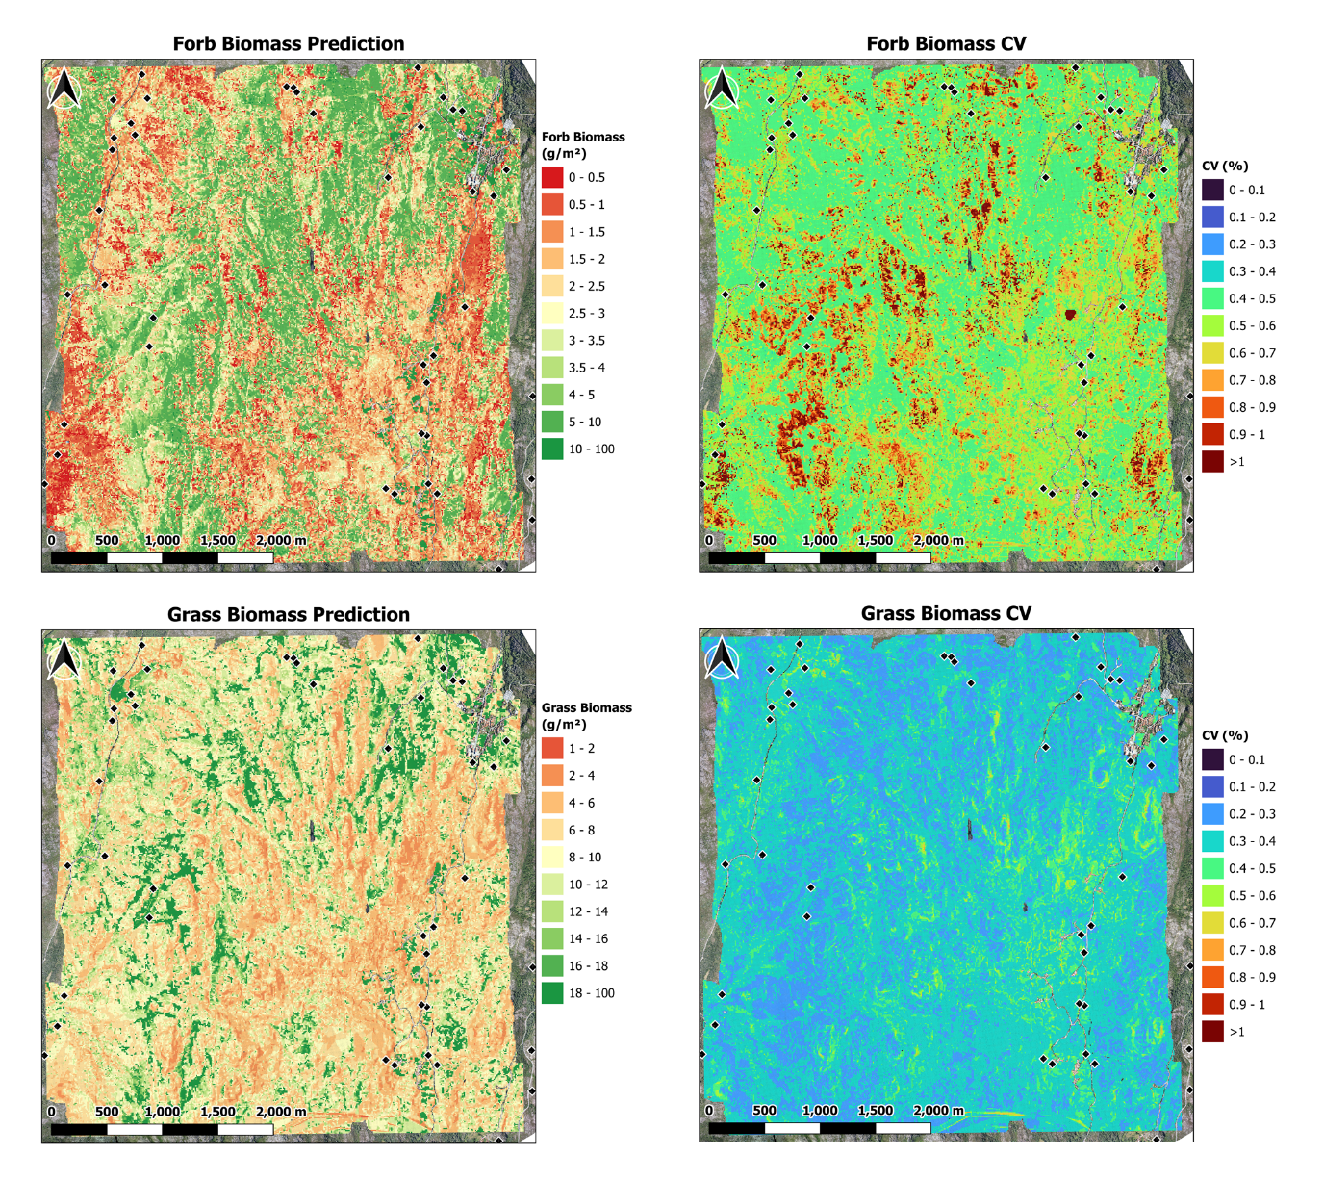

**S13.1 Observed and predicted HAB** per habitat type.

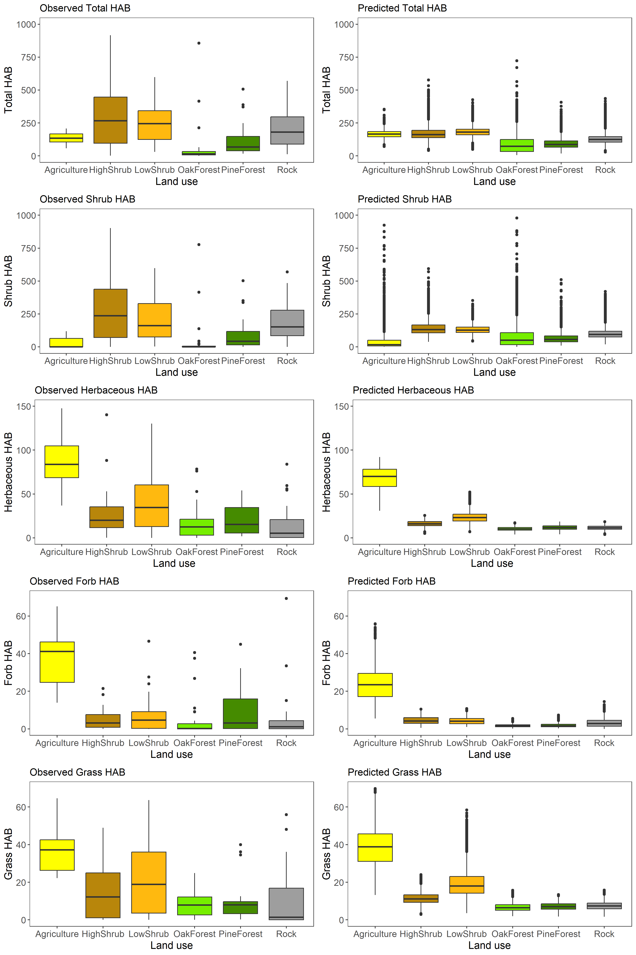

**S13.2 Predicted HAB and coefficient of variation (CV)** of the predictions per habitat type.

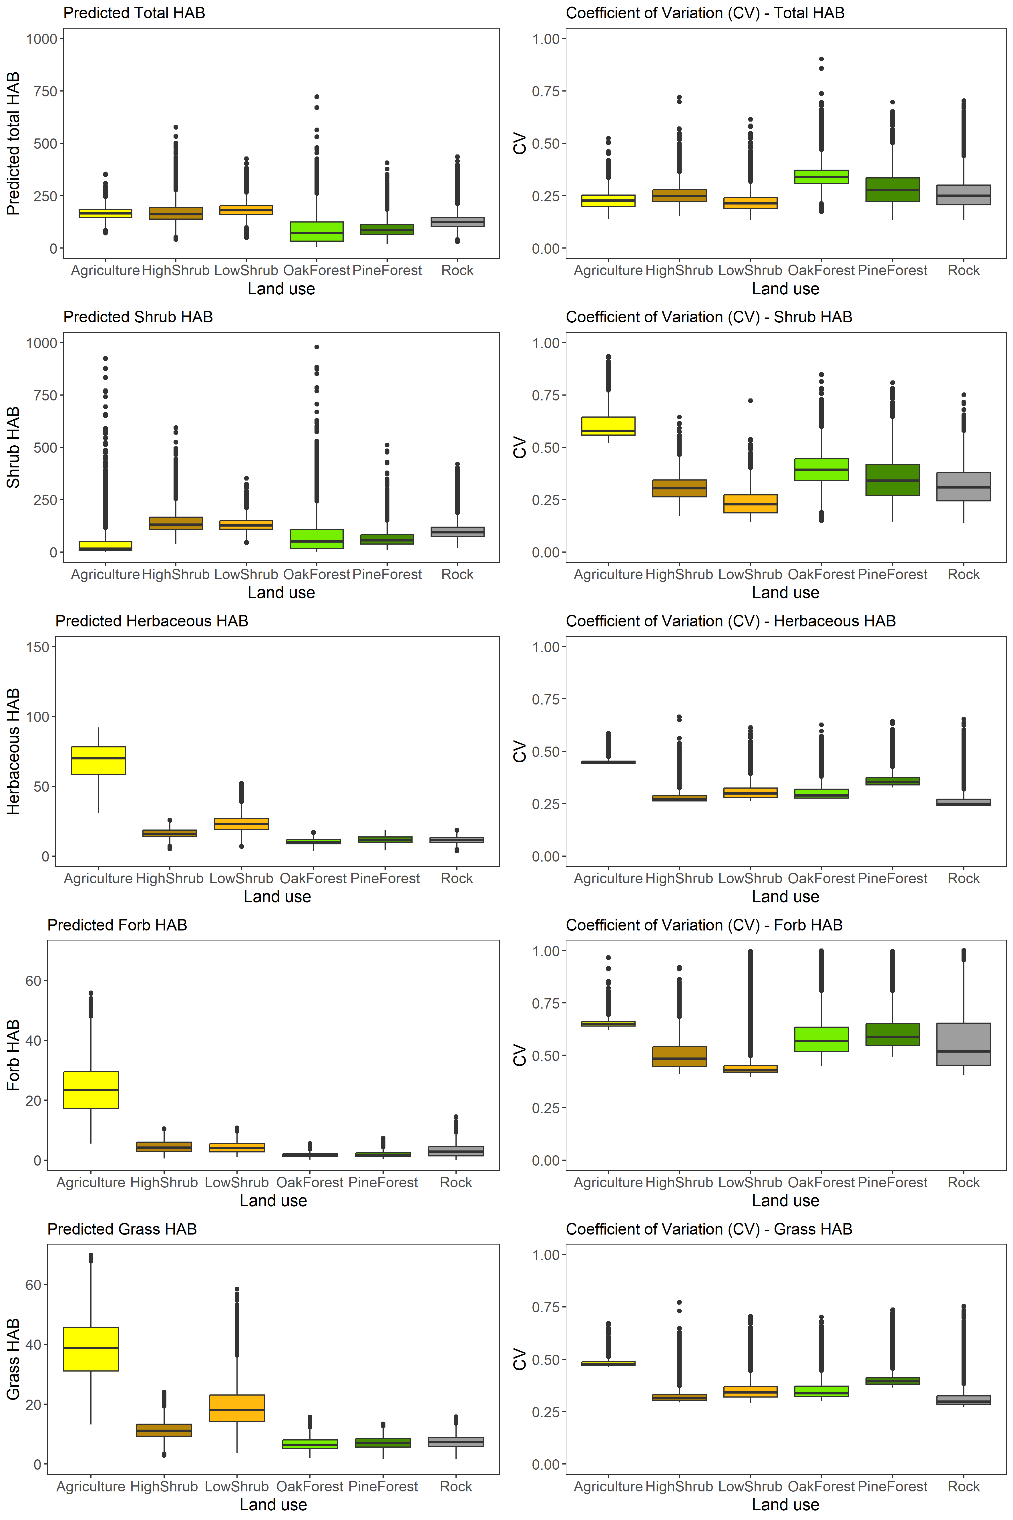

**S13.3. Histograms of HAB predictions**, standard errors and coefficients of variation across all vegetation types.

